中南大学

Web应用开发技术
实验报告

姓 名： | 王睿，陈钰岭
学 号： | 8209190511，8209190508
班 级： | 软件工程1905
指导老师： | 宋 铁
完成时间： | 2.3
分 数：
批阅日期：
实验一 基于MVC用JSP/Servlet实现JPetStore

- 实验内容——基本任务。
- 商品展示业务模块，包括大类Category、小类Product和具体商品Item的展示和搜索功能。

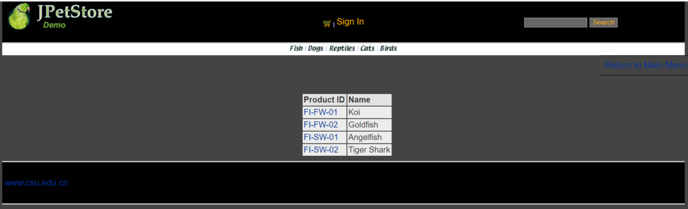

package org.csu.wr.web.servlets;
import org.csu.wr.domain.Account;
import org.csu.wr.domain.Category;
import org.csu.wr.domain.Product;
import org.csu.wr.service.CatalogService;
import org.csu.wr.service.LogService;
import javax.servlet.ServletException;
import javax.servlet.http.HttpServlet;
import javax.servlet.http.HttpServletRequest;
import javax.servlet.http.HttpServletResponse;
import javax.servlet.http.HttpSession;
import java.io.IOException;
import java.util.List;
/**
* Created by songtie on 2015/4/21.
*/
public class ViewCategoryServlet extends HttpServlet {
private static final String VIEW_CATEGORY = "/WEB-INF/jsp/catalog/Category.jsp";
private String categoryId;
protected void doPost(HttpServletRequest request, HttpServletResponse response) throws ServletException, IOException {
doGet(request, response);
}
protected void doGet(HttpServletRequest request, HttpServletResponse response) throws ServletException, IOException {
categoryId = request.getParameter("categoryId");
CatalogService service = new CatalogService();
Category category = service.getCategory(categoryId);
List<Product> productList = service.getProductListByCategory(categoryId);
HttpSession session = request.getSession();
session.setAttribute("category" , category);
session.setAttribute("productList" , productList);
Account account = (Account)session.getAttribute("user");
if(account != null) {
HttpServletRequest httpRequest = request;
String strBackUrl = "http://" + request.getServerName() + ":" + request.getServerPort()
+ httpRequest.getContextPath() + httpRequest.getServletPath() + "?" + (httpRequest.getQueryString());
LogService logService = new LogService();
//最后加入的信息“XXXXX”应当为该界面的信息以及一些商品信息
String logInfo = logService.logInfo(" ") + strBackUrl + " 查看目录";
logService.insertLogInfo(account.getUsername(), logInfo);
}
request.getRequestDispatcher(VIEW_CATEGORY).forward(request,response);
}
}

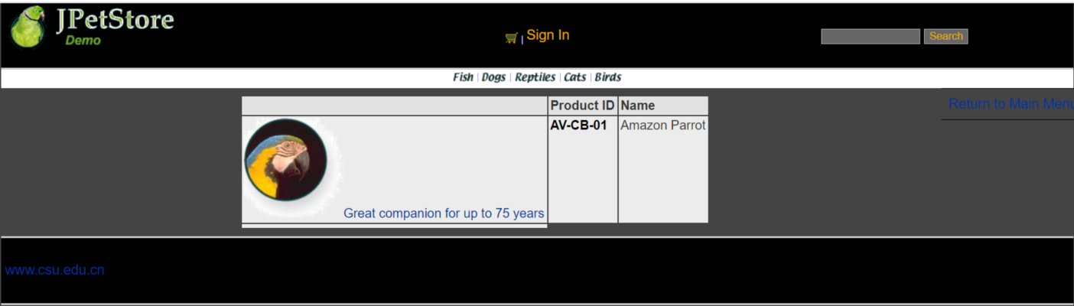
package org.csu.wr.web.servlets;
import org.csu.wr.domain.Account;
import org.csu.wr.domain.Item;
import org.csu.wr.domain.Product;
import org.csu.wr.service.CatalogService;
import org.csu.wr.service.LogService;
import javax.servlet.ServletException;
import javax.servlet.http.HttpServlet;
import javax.servlet.http.HttpServletRequest;
import javax.servlet.http.HttpServletResponse;
import javax.servlet.http.HttpSession;
import java.io.IOException;
import java.util.List;
/**
* Created by songtie on 2015/4/21.
*/
public class ViewProductServlet extends HttpServlet {
private static final String VIEW_PRODUCT = "/WEB-INF/jsp/catalog/Product.jsp";
private String productId;
protected void doPost(HttpServletRequest request, HttpServletResponse response) throws ServletException, IOException {
doGet(request, response);
}
protected void doGet(HttpServletRequest request, HttpServletResponse response) throws ServletException, IOException {
productId = request.getParameter("productId");
CatalogService service = new CatalogService();
Product product = service.getProduct(productId);
List<Item> itemList = service.getItemListByProduct(productId);
HttpSession session = request.getSession();
session.setAttribute("product", product);
session.setAttribute("itemList", itemList);
Account account = (Account)session.getAttribute("user");
if(account != null) {
HttpServletRequest httpRequest = request;
String strBackUrl = "http://" + request.getServerName() + ":" + request.getServerPort()
+ httpRequest.getContextPath() + httpRequest.getServletPath() + "?" + (httpRequest.getQueryString());
LogService logService = new LogService();
//最后加入的信息“XXXXX”应当为该界面的信息以及一些商品信息
String logInfo = logService.logInfo(" ") + strBackUrl + " 查看商品";
logService.insertLogInfo(account.getUsername(), logInfo);
}
request.getRequestDispatcher(VIEW_PRODUCT).forward(request,response);
}
}

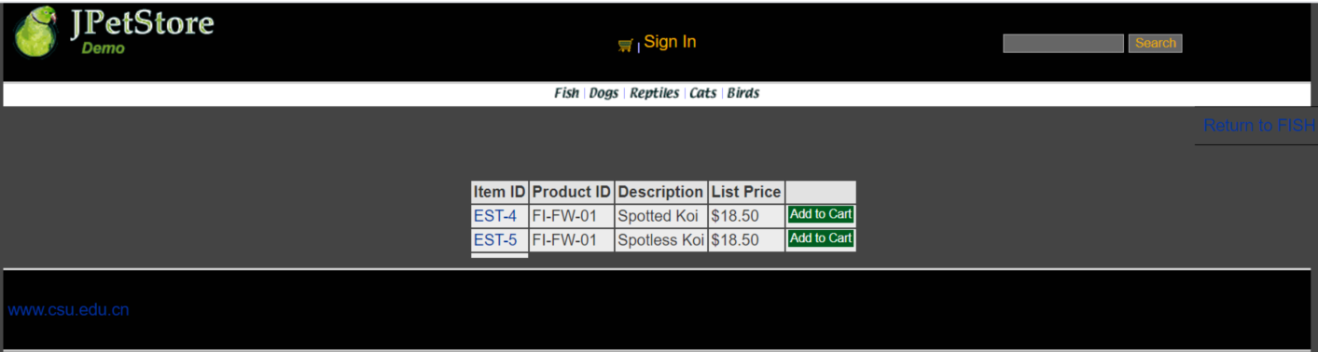
package org.csu.wr.web.servlets;
import org.csu.wr.domain.Account;
import org.csu.wr.domain.Item;
import org.csu.wr.service.CatalogService;
import org.csu.wr.service.LogService;
import javax.servlet.ServletException;
import javax.servlet.http.HttpServlet;
import javax.servlet.http.HttpServletRequest;
import javax.servlet.http.HttpServletResponse;
import javax.servlet.http.HttpSession;
import java.io.IOException;
/**
* Created by songtie on 2015/4/21.
*/
public class ViewItemServlet extends HttpServlet {
private static final String VIEW_ITEM = "/WEB-INF/jsp/catalog/Item.jsp";
private String itemId;
protected void doPost(HttpServletRequest request, HttpServletResponse response) throws ServletException, IOException {
doGet(request,response);
}
protected void doGet(HttpServletRequest request, HttpServletResponse response) throws ServletException, IOException {
itemId = request.getParameter("itemId");
CatalogService service = new CatalogService();
Item item = service.getItem(itemId);
HttpSession session = request.getSession();
session.setAttribute("item",item);
Account account = (Account)session.getAttribute("user");
if(account != null) {
HttpServletRequest httpRequest = request;
String strBackUrl = "http://" + request.getServerName() + ":" + request.getServerPort()
+ httpRequest.getContextPath() + httpRequest.getServletPath() + "?" + (httpRequest.getQueryString());
LogService logService = new LogService();
//最后加入的信息“XXXXX”应当为该界面的信息以及一些商品信息
String logInfo = logService.logInfo(" ") + strBackUrl + " 查看物品";
logService.insertLogInfo(account.getUsername(), logInfo);
}
request.getRequestDispatcher(VIEW_ITEM).forward(request,response);
}
}

搜索功能：
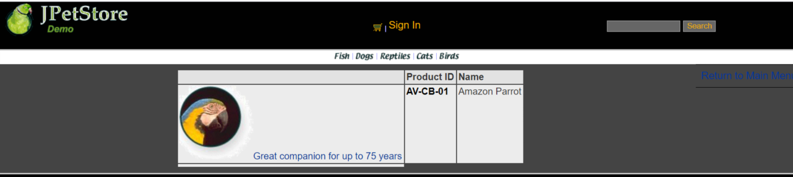
package org.csu.wr.web.servlets;
import org.csu.wr.domain.Account;
import org.csu.wr.domain.Product;
import org.csu.wr.service.CatalogService;
import org.csu.wr.service.LogService;
import javax.servlet.ServletException;
import javax.servlet.http.HttpServlet;
import javax.servlet.http.HttpServletRequest;
import javax.servlet.http.HttpServletResponse;
import javax.servlet.http.HttpSession;
import java.io.IOException;
import java.util.List;
/**
* Created by songtie on 2015/4/21.
*/
public class SearchProductServlet extends HttpServlet {
private static final String SEARCH_PRODUCT = "/WEB-INF/jsp/catalog/SearchProducts.jsp";
private String keyword;
protected void doPost(HttpServletRequest request, HttpServletResponse response) throws ServletException, IOException {
doGet(request,response);
}
protected void doGet(HttpServletRequest request, HttpServletResponse response) throws ServletException, IOException {
keyword = request.getParameter("keyword");
CatalogService service = new CatalogService();
List<Product> productList = service.searchProductList(keyword);
HttpSession session = request.getSession();
session.setAttribute("productList",productList);
Account account = (Account)session.getAttribute("user");
if(account != null) {
HttpServletRequest httpRequest = request;
String strBackUrl = "http://" + request.getServerName() + ":" + request.getServerPort()
+ httpRequest.getContextPath() + httpRequest.getServletPath() + "?" + (httpRequest.getQueryString());
LogService logService = new LogService();
//最后加入的信息“XXXXX”应当为该界面的信息以及一些商品信息
String logInfo = logService.logInfo(" ") + strBackUrl + " 查询动物";
logService.insertLogInfo(account.getUsername(), logInfo);
}
request.getRequestDispatcher(SEARCH_PRODUCT).forward(request,response);
}
}

- 用户管理业务模块，包括用户注册、登录、修改用户信息、查询用户相关订单等业务功能。

用户注册登录：
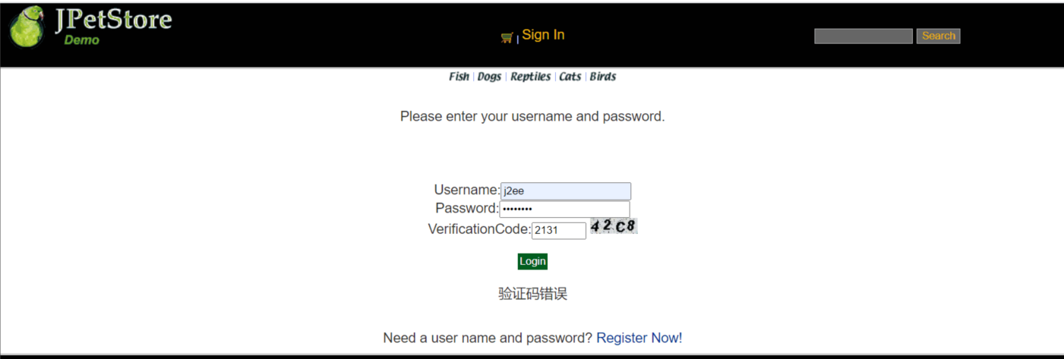


package org.csu.wr.web.servlets;
import org.csu.wr.domain.Account;
import org.csu.wr.service.ChangeInformation;
import org.csu.wr.service.LogService;
import org.csu.wr.service.loginService;
import javax.servlet.ServletException;
import javax.servlet.http.HttpServlet;
import javax.servlet.http.HttpServletRequest;
import javax.servlet.http.HttpServletResponse;
import javax.servlet.http.HttpSession;
import java.io.IOException;
public class InformationChangeServlet extends HttpServlet {
public static final String URL_BACK = "/WEB-INF/jsp/account/MyAccount.jsp";
@Override
protected void doGet(HttpServletRequest req, HttpServletResponse resp) throws ServletException, IOException {
String username =(String) req.getSession().getAttribute("username");
String password = req.getParameter("password");;
String repassword = req.getParameter("repeatedPassword");
String value1=req.getParameter("vCode");
String value2=(String)req.getSession().getAttribute("checkcode");
Boolean isSame = false;
if(value2.equalsIgnoreCase(value1)){
isSame = true;
}
if(req.getParameter("password")!="") {
if(!password.equals(repassword))
{
req.setAttribute("message","两次密码不一致");
req.getRequestDispatcher(URL_BACK).forward(req,resp);
}
else if (!isSame)
{
req.setAttribute("message","验证码错误");
req.getRequestDispatcher(URL_BACK).forward(req,resp);
}
else
{
password = req.getParameter("password");
}
}
else
{
password = (String)req.getSession().getAttribute("password");
}
String firstname = req.getParameter("account.firstName");
String lastname = req.getParameter("account.lastName");
String email = req.getParameter("account.email");
String phone = req.getParameter("account.phone");
String address1 = req.getParameter("account.address1");
String address2 = req.getParameter("account.address2");
String city = req.getParameter("account.city");
String state = req.getParameter("account.state");
String zip = req.getParameter("account.zip");
String country = req.getParameter("account.country");
ChangeInformation changeInformation = new ChangeInformation();
changeInformation.change_Account(username,password,email,firstname,lastname,address1,address2,city,state,zip,country,phone);
loginService login = new loginService();
Account account = login.existAccount(username,password);
req.getSession().setAttribute("user",account);
req.getSession().setAttribute("password",password);
req.getSession().setAttribute("username",account.getUsername());
req.getSession().setAttribute("Firstname",account.getFirstName());
req.getSession().setAttribute("Lastname",account.getLastName());
req.getSession().setAttribute("email",account.getEmail());
req.getSession().setAttribute("phone",account.getPhone());
req.getSession().setAttribute("Address1",account.getAddress1());
req.getSession().setAttribute("Address2",account.getAddress2());
req.getSession().setAttribute("city",account.getCity());
req.getSession().setAttribute("state",account.getState());
req.getSession().setAttribute("zip",account.getZip());
req.getSession().setAttribute("country",account.getCountry());
if(account != null) {
HttpServletRequest httpRequest = req;
String strBackUrl = "http://" + req.getServerName() + ":" + req.getServerPort()
+ httpRequest.getContextPath() + httpRequest.getServletPath() + "?" + (httpRequest.getQueryString());
LogService logService = new LogService();
//最后加入的信息“XXXXX”应当为该界面的信息以及一些商品信息
String logInfo = logService.logInfo(" ") + strBackUrl + " 修改账户信息";
logService.insertLogInfo(account.getUsername(), logInfo);
}
req.getRequestDispatcher(URL_BACK).forward(req,resp);
}
@Override
protected void doPost(HttpServletRequest req, HttpServletResponse resp) throws ServletException, IOException {
doGet(req, resp);
}
}

修改用户信息：
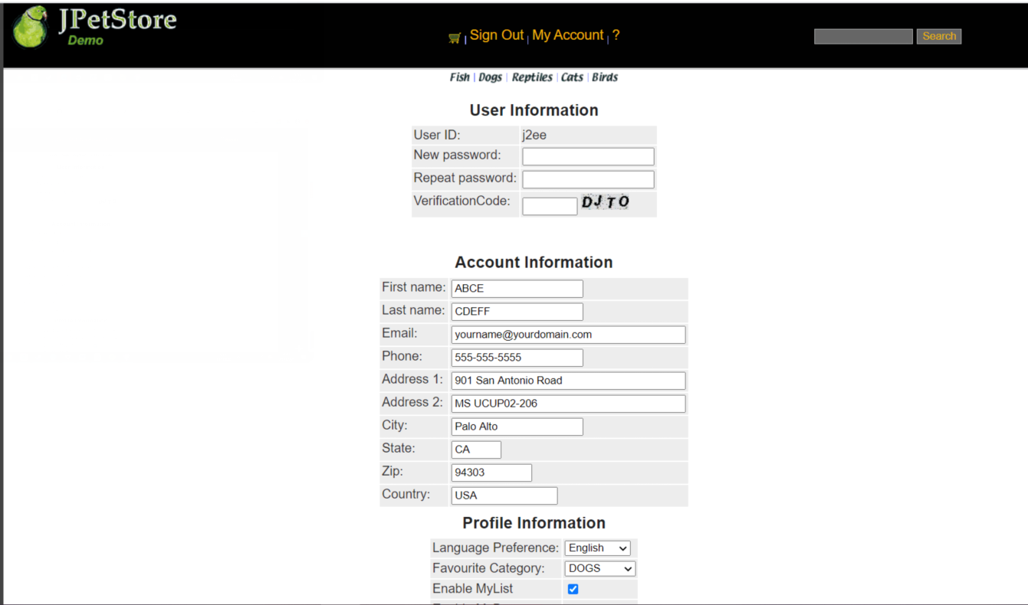
package org.csu.wr.web.servlets;
import org.csu.wr.domain.Account;
import org.csu.wr.persistence.impl.SignOnDAOImpl;
import org.csu.wr.service.LogService;
import javax.servlet.ServletException;
import javax.servlet.http.HttpServlet;
import javax.servlet.http.HttpServletRequest;
import javax.servlet.http.HttpServletResponse;
import javax.servlet.http.HttpSession;
import java.io.IOException;
public class Into_write_information_Servlet extends HttpServlet {
public static final String WRITE_INFORMATION_URL = "/WEB-INF/jsp/account/write_account_information.jsp";
public static final String Back_URL = "/WEB-INF/jsp/account/register.jsp";
@Override
protected void doGet(HttpServletRequest req, HttpServletResponse resp) throws ServletException, IOException {
SignOnDAOImpl signOnDAO = new SignOnDAOImpl();
boolean b = signOnDAO.ExistUser(req.getParameter("username"));
req.setAttribute("username",req.getParameter("username"));
if(req.getParameter("username").equals("") || req.getParameter("password").equals("")|| req.getParameter("repeatedPassword").equals("") )
{
req.setAttribute("message","请确保填完信息");
req.setAttribute("username",req.getParameter("username"));
HttpSession session = req.getSession();
Account account = (Account)session.getAttribute("user");
if(account != null) {
HttpServletRequest httpRequest = req;
String strBackUrl = "http://" + req.getServerName() + ":" + req.getServerPort()
+ httpRequest.getContextPath() + httpRequest.getServletPath() + "?" + (httpRequest.getQueryString());
LogService logService = new LogService();
//最后加入的信息“XXXXX”应当为该界面的信息以及一些商品信息
String logInfo = logService.logInfo(" ") + strBackUrl + " XXXXX";
logService.insertLogInfo(account.getUsername(), logInfo);
}
req.getRequestDispatcher(Back_URL).forward(req,resp);
}
else if(b)
{
req.setAttribute("message","用户名已被注册");
req.setAttribute("username",null);
HttpSession session = req.getSession();
Account account = (Account)session.getAttribute("user");
if(account != null) {
HttpServletRequest httpRequest = req;
String strBackUrl = "http://" + req.getServerName() + ":" + req.getServerPort()
+ httpRequest.getContextPath() + httpRequest.getServletPath() + "?" + (httpRequest.getQueryString());
LogService logService = new LogService();
//最后加入的信息“XXXXX”应当为该界面的信息以及一些商品信息
String logInfo = logService.logInfo(" ") + strBackUrl + " XXXXX";
logService.insertLogInfo(account.getUsername(), logInfo);
}
req.getRequestDispatcher(Back_URL).forward(req,resp);
}
else if(!req.getParameter("password" ).equals(req.getParameter("repeatedPassword")))
{
req.setAttribute("message","两次密码不一致");
req.setAttribute("username",req.getParameter("username"));
HttpSession session = req.getSession();
Account account = (Account)session.getAttribute("user");
if(account != null) {
HttpServletRequest httpRequest = req;
String strBackUrl = "http://" + req.getServerName() + ":" + req.getServerPort()
+ httpRequest.getContextPath() + httpRequest.getServletPath() + "?" + (httpRequest.getQueryString());
LogService logService = new LogService();
//最后加入的信息“XXXXX”应当为该界面的信息以及一些商品信息
String logInfo = logService.logInfo(" ") + strBackUrl + " XXXXX";
logService.insertLogInfo(account.getUsername(), logInfo);
}
req.getRequestDispatcher(Back_URL).forward(req,resp);
}
else
{
req.getSession().setAttribute("username",req.getParameter("username"));
req.getSession().setAttribute("password",req.getParameter("password"));
req.getRequestDispatcher(WRITE_INFORMATION_URL).forward(req,resp);
}
}
@Override
protected void doPost(HttpServletRequest req, HttpServletResponse resp) throws ServletException, IOException {
doGet(req, resp);
}
}
查询用户相关订单：
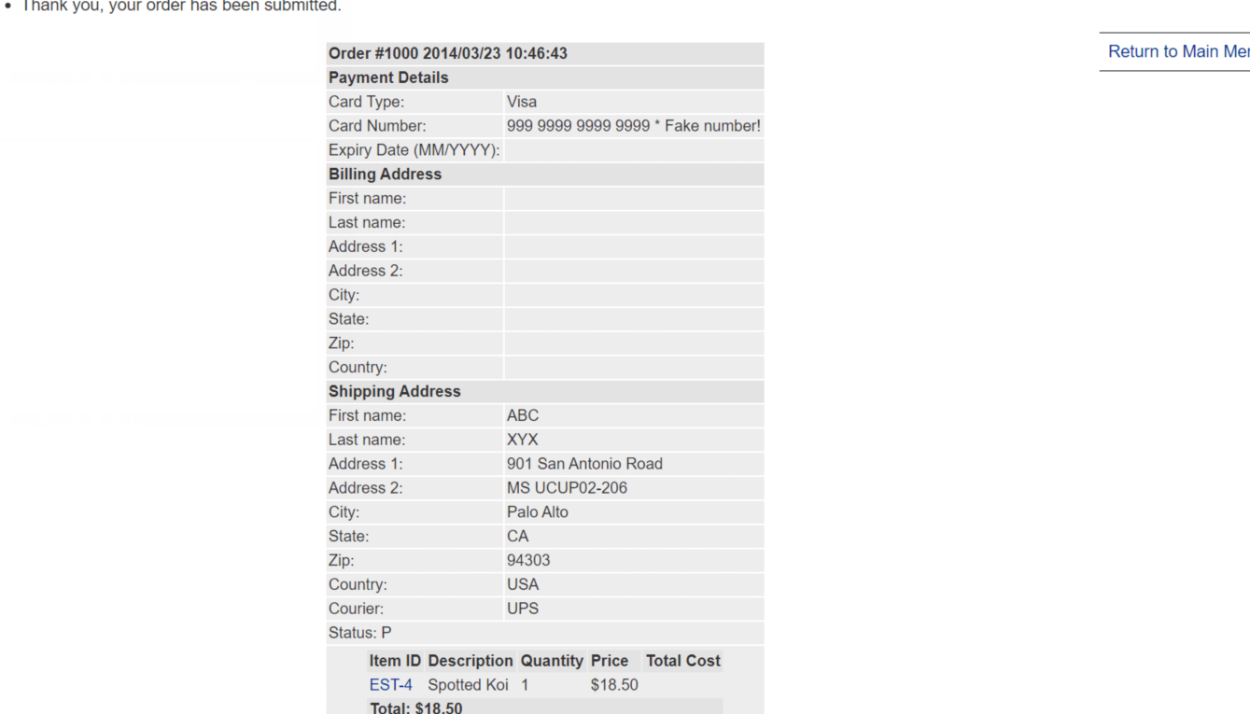
package org.csu.wr.web.servlets;
import org.csu.wr.domain.Account;
import org.csu.wr.domain.Product;
import org.csu.wr.service.CatalogService;
import org.csu.wr.service.LogService;
import javax.servlet.ServletException;
import javax.servlet.http.HttpServlet;
import javax.servlet.http.HttpServletRequest;
import javax.servlet.http.HttpServletResponse;
import javax.servlet.http.HttpSession;
import java.io.IOException;
import java.util.List;
/**
* Created by songtie on 2015/4/21.
*/
public class SearchProductServlet extends HttpServlet {
private static final String SEARCH_PRODUCT = "/WEB-INF/jsp/catalog/SearchProducts.jsp";
private String keyword;
protected void doPost(HttpServletRequest request, HttpServletResponse response) throws ServletException, IOException {
doGet(request,response);
}
protected void doGet(HttpServletRequest request, HttpServletResponse response) throws ServletException, IOException {
keyword = request.getParameter("keyword");
CatalogService service = new CatalogService();
List<Product> productList = service.searchProductList(keyword);
HttpSession session = request.getSession();
session.setAttribute("productList",productList);
Account account = (Account)session.getAttribute("user");
if(account != null) {
HttpServletRequest httpRequest = request;
String strBackUrl = "http://" + request.getServerName() + ":" + request.getServerPort()
+ httpRequest.getContextPath() + httpRequest.getServletPath() + "?" + (httpRequest.getQueryString());
LogService logService = new LogService();
//最后加入的信息“XXXXX”应当为该界面的信息以及一些商品信息
String logInfo = logService.logInfo(" ") + strBackUrl + " 查询动物";
logService.insertLogInfo(account.getUsername(), logInfo);
}
request.getRequestDispatcher(SEARCH_PRODUCT).forward(request,response);
}
}

- 订单管理模块，包括购物车管理、新增订单、地址信息等业务功能。

购物车管理：

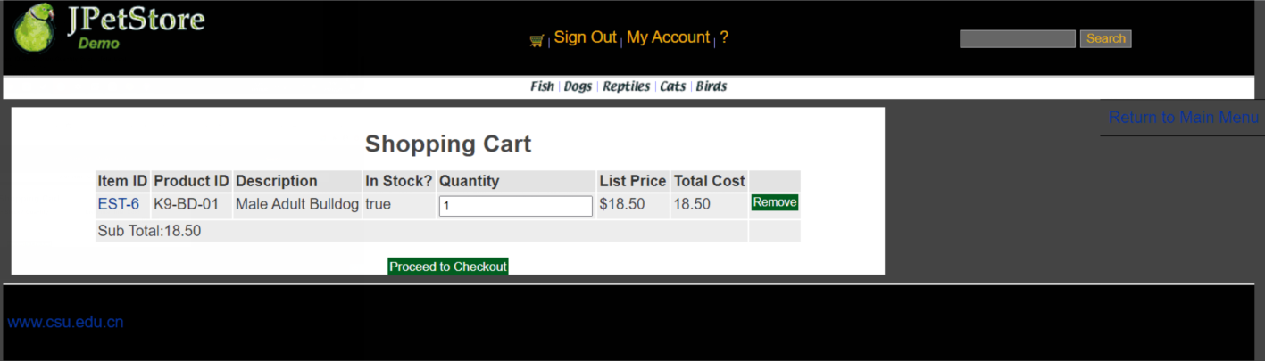
package org.csu.wr.web.servlets;
import org.csu.wr.domain.Account;
import org.csu.wr.domain.Cart;
import org.csu.wr.domain.CartItem;
import org.csu.wr.service.LogService;
import javax.servlet.ServletException;
import javax.servlet.http.HttpServlet;
import javax.servlet.http.HttpServletRequest;
import javax.servlet.http.HttpServletResponse;
import javax.servlet.http.HttpSession;
import java.io.IOException;
import java.util.Iterator;
/**
* Created by songtie on 2015/4/27.
*/
public class UpdateCartQuantitiesServlet extends HttpServlet {
private static final String VIEW_CART = "/WEB-INF/jsp/cart/Cart.jsp";
private static final String ERROR = "/WEB-INF/jsp/common/Error.jsp";
private Cart cart;
protected void doPost(HttpServletRequest request, HttpServletResponse response) throws ServletException, IOException {
doGet(request, response);
}
protected void doGet(HttpServletRequest request, HttpServletResponse response) throws ServletException, IOException {
HttpSession session = request.getSession();
cart = (Cart) session.getAttribute("cart");
Iterator<CartItem> cartItems = cart.getAllCartItems();
while (cartItems.hasNext()) {
CartItem cartItem = cartItems.next();
String itemId = cartItem.getItem().getItemId();
try {
int quantity = Integer.parseInt(request.getParameter(itemId));
cart.setQuantityByItemId(itemId, quantity);
if (quantity < 1) {
cartItems.remove();
}
} catch (Exception e) {
session.setAttribute("message", "The Quantities of Item must be Integer!");
Account account = (Account)session.getAttribute("user");
if(account != null) {
HttpServletRequest httpRequest = request;
String strBackUrl = "http://" + request.getServerName() + ":" + request.getServerPort()
+ httpRequest.getContextPath() + httpRequest.getServletPath() + "?" + (httpRequest.getQueryString());
LogService logService = new LogService();
//最后加入的信息“XXXXX”应当为该界面的信息以及一些商品信息
String logInfo = logService.logInfo(" ") + strBackUrl + " XXXXX";
logService.insertLogInfo(account.getUsername(), logInfo);
}
request.getRequestDispatcher(ERROR).forward(request, response);
}
}
Account account = (Account)session.getAttribute("user");
if(account != null) {
HttpServletRequest httpRequest = request;
String strBackUrl = "http://" + request.getServerName() + ":" + request.getServerPort()
+ httpRequest.getContextPath() + httpRequest.getServletPath() + "?" + (httpRequest.getQueryString());
LogService logService = new LogService();
//最后加入的信息“XXXXX”应当为该界面的信息以及一些商品信息
String logInfo = logService.logInfo(" ") + strBackUrl + " 更新购物车价格";
logService.insertLogInfo(account.getUsername(), logInfo);
}
request.getRequestDispatcher(VIEW_CART).forward(request, response);
}
}

新增订单：
package org.csu.wr.web.servlets;
import org.csu.wr.domain.Account;
import org.csu.wr.domain.Cart;
import org.csu.wr.domain.Item;
import org.csu.wr.service.CatalogService;
import org.csu.wr.service.LogService;
import javax.servlet.ServletException;
import javax.servlet.http.HttpServlet;
import javax.servlet.http.HttpServletRequest;
import javax.servlet.http.HttpServletResponse;
import javax.servlet.http.HttpSession;
import java.io.IOException;
/**
* Created by songtie on 2015/4/27.
*/
public class AddItemToCartServlet extends HttpServlet {
//1. ��������������תҳ��
private static final String VIEW_CART = "/WEB-INF/jsp/cart/Cart.jsp";
//2. ���崦�����������Ҫ������
private String workingItemId;
private Cart cart;
//3. �Ƿ���Ҫ����ҵ���߼���
private CatalogService catalogService;
protected void doPost(HttpServletRequest request, HttpServletResponse response) throws ServletException, IOException {
doGet(request, response);
}
protected void doGet(HttpServletRequest request, HttpServletResponse response) throws ServletException, IOException {
workingItemId = request.getParameter("workingItemId");
HttpSession session = request.getSession();
cart = (Cart)session.getAttribute("cart");
if (cart == null) {
cart = new Cart();
}
if (cart.containsItemId(workingItemId)) {
cart.incrementQuantityByItemId(workingItemId);
} else {
catalogService = new CatalogService();
boolean isInStock = catalogService.isItemInStock(workingItemId);
Item item = catalogService.getItem(workingItemId);
cart.addItem(item, isInStock);
}
session.setAttribute("cart", cart);
Account account = (Account)session.getAttribute("user");
if(account != null) {
HttpServletRequest httpRequest = request;
String strBackUrl = "http://" + request.getServerName() + ":" + request.getServerPort()
+ httpRequest.getContextPath() + httpRequest.getServletPath() + "?" + (httpRequest.getQueryString());
LogService logService = new LogService();
//最后加入的信息“XXXXX”应当为该界面的信息以及一些商品信息
String logInfo = logService.logInfo(" ") + strBackUrl + " 将物品加入购物车";
logService.insertLogInfo(account.getUsername(), logInfo);
}
request.getRequestDispatcher(VIEW_CART).forward(request, response);
}
}

地址信息：

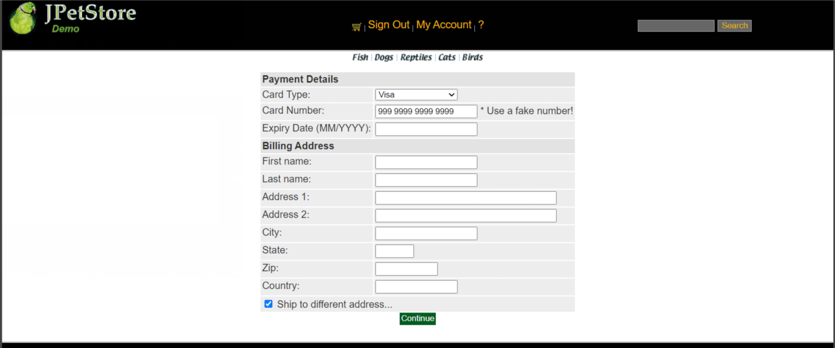
<%@ page contentType="text/html;charset=UTF-8" language="java" %>
<%@ include file="../common/IncludeTop.jsp"%>
<div id="Content">
<div id="Catalog">
<form action="comfirmOrder">
<table>
<tbody><tr>
<th colspan="2">Payment Details</th>
</tr>
<tr>
<td>Card Type:</td>
<td><select name="order.cardType">
<option selected="selected" value="Visa">Visa</option>
<option value="MasterCard">MasterCard</option>
<option value="American Express">American Express</option>
</select></td>
</tr>
<tr>
<td>Card Number:</td>
<td><input name="order.creditCard" value="999 9999 9999 9999" type="text"> * Use a fake
number!</td>
</tr>
<tr>
<td>Expiry Date (MM/YYYY):</td>
<td><input name="order.expiryDate" value="" type="text"></td>
</tr>
<tr>
<th colspan="2">Billing Address</th>
</tr>
<tr>
<td>First name:</td>
<td><input name="order.billToFirstName" value="" type="text"></td>
</tr>
<tr>
<td>Last name:</td>
<td><input name="order.billToLastName" value="" type="text"></td>
</tr>
<tr>
<td>Address 1:</td>
<td><input name="order.billAddress1" value="" type="text" size="40"></td>
</tr>
<tr>
<td>Address 2:</td>
<td><input name="order.billAddress2" value="" type="text" size="40"></td>
</tr>
<tr>
<td>City:</td>
<td><input name="order.billCity" value="" type="text"></td>
</tr>
<tr>
<td>State:</td>
<td><input name="order.billState" value="" type="text" size="4"></td>
</tr>
<tr>
<td>Zip:</td>
<td><input name="order.billZip" value="" type="text" size="10"></td>
</tr>
<tr>
<td>Country:</td>
<td><input name="order.billCountry" value="" type="text" size="15"></td>
</tr>
<tr>
<td colspan="2"><input name="shippingAddressRequired" value="true" type="checkbox">
Ship to different address...</td>
</tr>
</tbody></table>
<input name="newOrder" value="Continue" type="submit">
</form>
</div>
</div>
<%@ include file="../common/IncludeBottom.jsp"%>

//以上三个业务模块，用运行界面截图和核心代码展示功能完成情况。
- 实验内容——扩展任务。
- 添加验证码功能：在用户注册和用户登录模块中添加验证码功能。
验证码实现的基本原理：
先将验证码设置为字母和数字，接下产生随机验证码，根据产生的验证码产生图画，将验证码的图形传到客户端。
实现方案：通过VerificationCode.JaVa实现随机数字和字母组成图片的功能，在登录页面和账户页面添加验证码功能，再分别获取图片和用户输入的数据，判断是否一致。

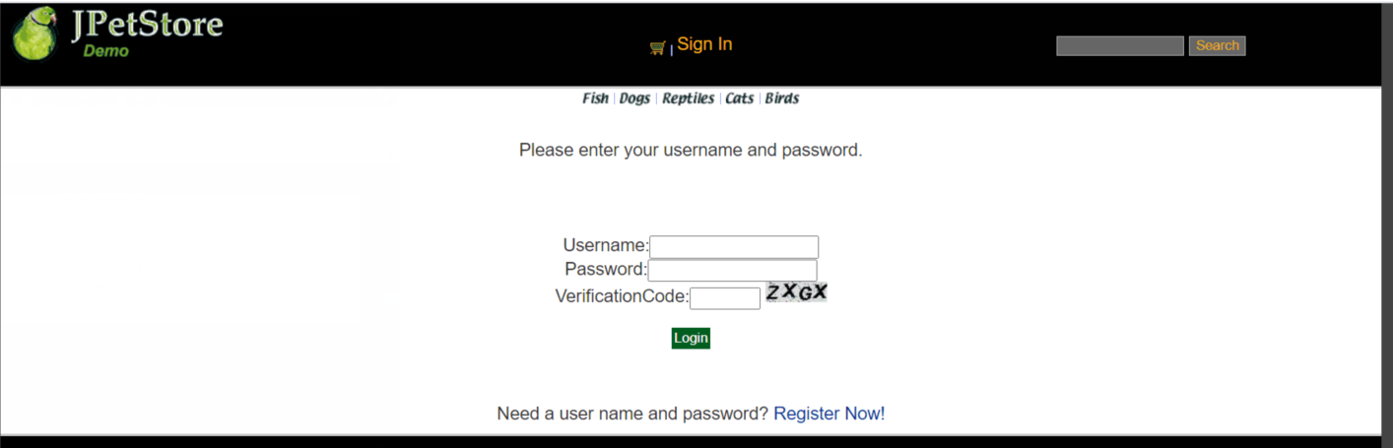
package org.csu.wr.web.servlets;
import javax.imageio.ImageIO;
import javax.servlet.*;
import javax.servlet.ServletException;
import javax.servlet.http.HttpServlet;
import javax.servlet.http.HttpServletRequest;
import javax.servlet.http.HttpServletResponse;
import javax.servlet.http.HttpSession;
import java.awt.*;
import java.awt.image.BufferedImage;
import java.io.ByteArrayOutputStream;
import java.io.IOException;
import java.util.Iterator;
public class VerificationCode extends HttpServlet {
public void doPost(HttpServletRequest req, HttpServletResponse resp)
throws ServletException, IOException {
doGet(req, resp);
}
@Override
protected void doGet(HttpServletRequest req, HttpServletResponse resp) throws ServletException, IOException {
resp.setContentType("image/jpeg");
HttpSession session=req.getSession();
int width=60;
int height=20;
//设置浏览器不要缓存此图片
resp.setHeader("Pragma", "No-cache");
resp.setHeader("Cache-Control", "no-cache");
resp.setDateHeader("Expires", 0);
//创建内存图像并获得图形上下文
BufferedImage image=new BufferedImage(width, height,BufferedImage.TYPE_INT_RGB);
Graphics g=image.getGraphics();
/*
* 产生随机验证码
* 定义验证码的字符表
*/
String chars="0123456789ABCDEFGHIJKLMNOPQRSTUVWXYZ";
char[] rands=new char[4];
for(int i=0;i<4;i++){
int rand=(int) (Math.random() *36);
rands[i]=chars.charAt(rand);
}
/*
* 产生图像
* 画背景
*/
g.setColor(new Color(0xDCDCDC));
g.fillRect(0, 0, width, height);
/*
* 随机产生120个干扰点
*/
for(int i=0;i<120;i++){
int x=(int)(Math.random()*width);
int y=(int)(Math.random()*height);
int red=(int)(Math.random()*255);
int green=(int)(Math.random()*255);
int blue=(int)(Math.random()*255);
g.setColor(new Color(red,green,blue));
g.drawOval(x, y, 1, 0);
}
g.setColor(Color.BLACK);
g.setFont(new Font(null, Font.ITALIC|Font.BOLD,18));
//在不同高度输出验证码的不同字符
g.drawString(""+rands[0], 1, 17);
g.drawString(""+rands[1], 16, 15);
g.drawString(""+rands[2], 31, 18);
g.drawString(""+rands[3], 46, 16);
g.dispose();
//将图像传到客户端
ServletOutputStream sos=resp.getOutputStream();
ByteArrayOutputStream baos=new ByteArrayOutputStream();
ImageIO.write(image, "JPEG", baos);
byte[] buffer=baos.toByteArray();
resp.setContentLength(buffer.length);
sos.write(buffer);
baos.close();
sos.close();
session.setAttribute("checkcode", new String(rands));
}
public void init() throws ServletException {
// Put your code here
}
}

- 购物车功能：原项目中购物车为内存购物车，即将用户相关的购物车存储在session中；在数据库中添加购物车表，将购物车数据持久化，以便用户下次登录时可查看或修改自己的购物车数据。

package org.csu.wr.service;
import org.csu.wr.domain.Category;
import org.csu.wr.domain.Product;
import org.csu.wr.domain.Item;
import org.csu.wr.persistence.CategoryDAO;
import org.csu.wr.persistence.ItemDAO;
import org.csu.wr.persistence.ProductDAO;
import org.csu.wr.persistence.impl.CategoryDAOImpl;
import org.csu.wr.persistence.impl.ItemDAOImpl;
import org.csu.wr.persistence.impl.ProductDAOImpl;
import java.util.List;
/**
* Created by songtie on 2015/4/21.
*/
public class CatalogService
{
private CategoryDAO categoryDAO;
private ProductDAO productDAO;
private ItemDAO itemDAO;
public CatalogService()
{
categoryDAO = new CategoryDAOImpl();
productDAO = new ProductDAOImpl();
itemDAO = new ItemDAOImpl();
}
public List<Category> getCategoryList() {
return categoryDAO.getCategoryList();
}
public Category getCategory(String categoryId) {
return categoryDAO.getCategory(categoryId);
}
public Product getProduct(String productId) {
return productDAO.getProduct(productId);
}
public List<Product> getProductListByCategory(String categoryId) {
return productDAO.getProductListByCategory(categoryId);
}
// TODO enable using more than one keyword
public List<Product> searchProductList(String keyword) {
return productDAO.searchProductList("%" + keyword.toLowerCase() + "%");
}
public List<Item> getItemListByProduct(String productId) {
return itemDAO.getItemListByProduct(productId);
}
public Item getItem(String itemId) {
return itemDAO.getItem(itemId);
}
public boolean isItemInStock(String itemId) {
return itemDAO.getInventoryQuantity(itemId) > 0;
}
}

- 日志功能：数据库中添加日志信息表，给项目添加日志功能，用户登录后记录用户行为，比如浏览了哪些商品、将商品添加进购物车、生成订单等。

能够记录的有：用户账号、跳转时间、商品信息等
怎么记录：通过各种方法获取用户进行操作时用户的信息以及当时的时间等信息，将其插入到数据库中记录下来。
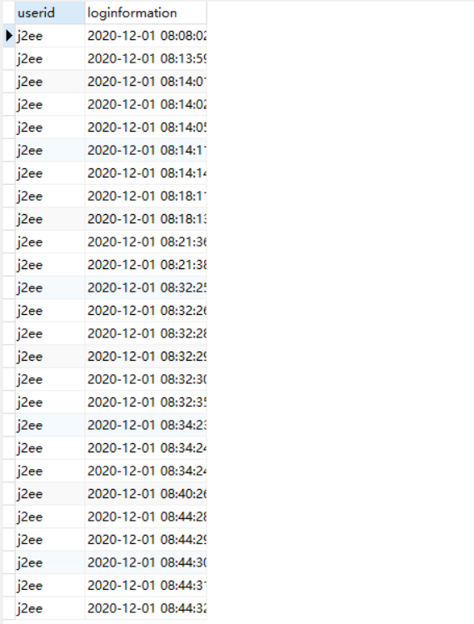
package org.csu.wr.service;
import org.csu.wr.domain.Log;
import org.csu.wr.persistence.LogDAO;
import org.csu.wr.persistence.impl.LogDAOImpl;
public class LogService {
Log log;
private LogDAO logDAO;
public LogService(){
log = new Log();
logDAO = new LogDAOImpl();
}
public String logInfo(Object ...s){
return log.logInfomation(s);
}
public void insertLogInfo(String username, String logInfo){
logDAO.insertLog(username, logInfo);
}

//以上两个扩展任务，除用界面截图和核心代码展示功能完成情况外，验证码功能还需说明验证码的基本原理和实现方案，日志功能需描述项目所完成的功能情况（能记录哪些日志、怎么记录等）。
- 小组成员分工及实验总结
- 小组分工：

王睿为组长负责实现商品展示业务模块、用户管理业务模块、购物车功能以及添加验证码功能，陈钰岭负责实现订单管理模块、数据库、日志功能。
- 实验总结
我们小组在开始进行这个项目时，首先要解决的问题是如何连上数据库。因为已经有老师的模板，所以我们只需要对项目进行完善。首先要解决的就是数据库的问题，这部分由陈钰岭完成，在电脑上弄好配置后，我们首先要将已有的数据库导入到我们的项目中，将数据库导入到项目后，我们要在项目中与数据库建立联系，这一部分老师的视频中已经讲述过，所以跟着做即可。将数据库导入到项目中后，点开项目即可看到项目的基本内容，此时我们可以看到项目大致的雏形，只是其中的许多功能还未实现。接下来我们要进行的是对项目的功能实现，项目的功能实现主要有购物车功能、用户管理模块、订单管理模块等。用户管理模块和订单管理模块我们小组遇到的问题较少，主要是在编写的过程中要细心不要出错，每个servlet和Dao文件认真写即可。
我们小组在购物车功能遇到了一些问题。我们的问题是如何实现在项目中点击添加购物车后 ，购物车中出现我们添加的商品。后来我们运用servlet技术实现了购物车的购买功能，使得我们的购物车中点击添加至购物车后界面中的购物车能够显示我们添加的商品，同时这些商品也会出现在我们的数据库中。 之后我们又致力于解决欸之功能，并顺利的实现了。
通过这次的实验，我们更加深入了对servlet和jsp的理解以及熟练运用，通过对代码的编写以及在编写过程中的自己的学习以及理解，我们学习了很多我们不熟悉的知识，在学习中成长，成为更好的自己。
实验二 使用AJAX和jQuery改善用户体验
- 实验内容——基本任务。
- 账号管理模块。在新建账号和修改账号信息页面上用AJAX技术进行表单验证，如“判断用户名是否已存在”等功能。

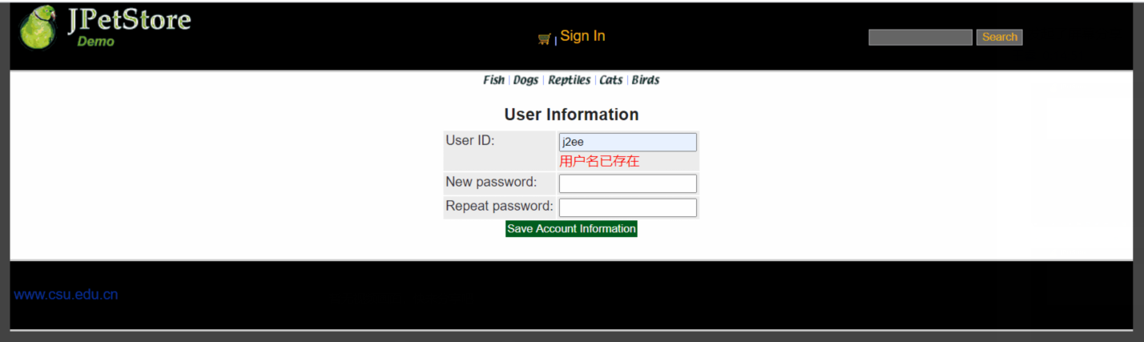
var httpRequest=null;
function createXMLHttpRequest(){
if(window.XMLHttpRequest) {
httpRequest = new XMLHttpRequest();
} else if (window.ActiveXObject) {
httpRequest = new ActiveXObject("Microsoft.XMLHTTP");
}
}
function usernameIsExist() {
var username = document.getElementById('username').value;
sendRequest("usernameIsExistServlet?username=" + username);
}
function sendRequest(url) {
createXMLHttpRequest();
httpRequest.open("GET",url,true);
httpRequest.onreadystatechange=processResponse;
httpRequest.send(null);
}
function processResponse() {
if (httpRequest.readyState == 4) {
if (httpRequest.status == 200) {
var responseInfo = httpRequest.responseXML.getElementsByTagName("msg")[0].firstChild.data;
var div1 = document.getElementById('usernameMsg');
if (responseInfo == "Exist") {
div1.innerHTML = "<font color='red'>用户名已存在</font>";
} else {
div1.innerHTML = "<font color='green'>用户名可用</font>";
}
}
}
}

- 查询商品模块。在主页面右上角的查询商品功能中添加自动补全功能。

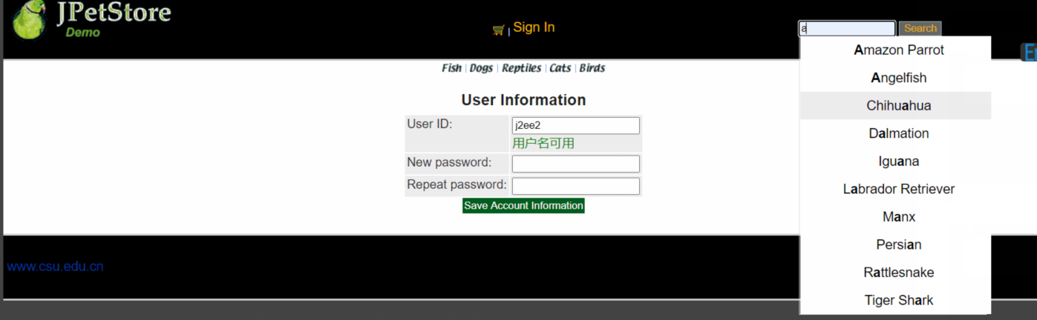
Array.prototype.unique = function(){
this.sort();
var res = [];
var json = {};
for (var i = 0; i < this.length; i++) {
if(!json[this[i]]){
res.push(this[i]);
json[this[i]] = 1;
}
}
return res;
}
// 对样式操作
var setClass = {
hasClass: function(elements,cName){ // 判断是否含有某个class
if(elements.className.match(new RegExp( "(\\s|^)" + cName + "(\\s|$)") ))
return true;
else
return false;
},
addClass: function(elements,cName){ // 添加class
if( !this.hasClass( elements,cName ) ){
elements.className += " " + cName;
};
},
removeClass: function(elements,cName){ // 移除某个class
if( this.hasClass( elements,cName ) ){
elements.className = elements.className.replace( new RegExp( "(\\s|^)" + cName + "(\\s|$)" )," " );
}
}
}
var Bind = function(This){
return function(){
This.init();
}
}
function AutoComplete(keyword,auto,arr) {
this.obj = document.getElementById(keyword);
this.autoObj = document.getElementById(auto);
this.search_value = ""; //当前的搜索输入值
this.index = -1; //当前选中的DIV的索引
this.value_arr = arr; //数据库中供检索的值 不包含重复值
}
AutoComplete.prototype = {
// 初始化
init: function(){
var This = this;
setClass.removeClass(This.autoObj,"hidden");
this.autoObj.style.left = this.obj.offsetLeft + "px";
this.autoObj.style.top = this.obj.offsetTop + this.obj.offsetHeight + "px";
},
//删除自动完成需要的所有DIV
deleteDIV: function(){
while(this.autoObj.hasChildNodes()){
this.autoObj.removeChild(this.autoObj.firstChild);
}
setClass.addClass(this.autoObj,"hidden");
},
autoOnmouseover: function(index){
if(index != this.index){
setClass.addClass(this.autoObj.children[index],"on");
setClass.removeClass(this.autoObj.children[this.index],"on");
this.index = index;
}
},
setValue: function(This){
return function(){
This.obj.value = this.seq;
setClass.addClass(This.autoObj,"hidden");
}
},
// 响应键盘
pressKey: function(event){
var code = event.keyCode;
var length = this.autoObj.children.length;
if(code == 38){ //↑
setClass.removeClass(this.autoObj.children[this.index],"on");
this.index--;
if(this.index < 0){
this.index = length - 1;
}
setClass.addClass(this.autoObj.children[this.index],"on");
this.obj.value = this.autoObj.children[this.index].seq;
}else if(code == 40){ //↓
setClass.removeClass(this.autoObj.children[this.index],"on");
this.index++;
if(this.index > length-1){
this.index = 0;
}
setClass.addClass(this.autoObj.children[this.index],"on");
this.obj.value = this.autoObj.children[this.index].seq;
}else{ //回车
this.obj.value = this.autoObj.children[this.index].seq;
setClass.addClass(this.autoObj,"hidden");
this.index = -1;
}
},
// 程序入口
start: function(event){
event = event || window.event;
var code = event.keyCode;
var This = this;
if(code != 13 && code != 38 && code != 40){
this.init();
this.deleteDIV();
this.search_value = this.obj.value;
var valueArr = this.value_arr.unique();
//去掉前后空格不能为空
if(this.obj.value.replace(/(^\s*)|(\s*$)/g,"") == ""){ return;}
//判断数组中是否含有输入的关键字
try{
var reg = new RegExp("("+ this.obj.value +")","i"); //输入"aaa" 则 reg = /(aaa)/i
}catch(e){
alert(e.message);
}
var div_index = 0; //记录匹配索引个数
for (var i = 0; i < valueArr.length; i++) {
if(reg.test(valueArr[i])){
var div = document.createElement("div");
div.className = "auto_out";
div.seq = valueArr[i];
div.index = div_index;
div.innerHTML = valueArr[i].replace(reg,"<strong>$1</strong>");
this.autoObj.appendChild(div);
setClass.removeClass(this.autoObj,"hidden");
div_index++;
if(div_index == 1) {
setClass.addClass(this.autoObj.firstChild,"on");
this.index = 0;
}
div.onmouseover = function(){
This.autoOnmouseover(this.index);
}
div.onclick = this.setValue(This);
}
}
}else{
this.pressKey(event);
}
window.onresize = Bind(This);
}
}
var httpRequest=null;
function createXMLHttpRequest(){
if(window.XMLHttpRequest) {
httpRequest = new XMLHttpRequest();
} else if (window.ActiveXObject) {
httpRequest = new ActiveXObject("Microsoft.XMLHTTP");
}
}
var keyword = document.getElementById('keyword').value;
sendRequest("findResultServlet?keyword=" + keyword);
function sendRequest(url) {
createXMLHttpRequest();
httpRequest.open("GET",url,true);
httpRequest.onreadystatechange=processResponse;
httpRequest.send(null);
}
function processResponse() {
if (httpRequest.readyState == 4) {
if (httpRequest.status == 200) {
var resp = httpRequest.responseText;
var array = resp.split(",");
var autoComplete = new AutoComplete("keyword","auto",array);
document.getElementById("keyword").onkeyup = function(event){
autoComplete.start(event);
}
}
}

- 购物车模块。在购物车模块中修改购买数量时，通过AJAX修改购物车信息。

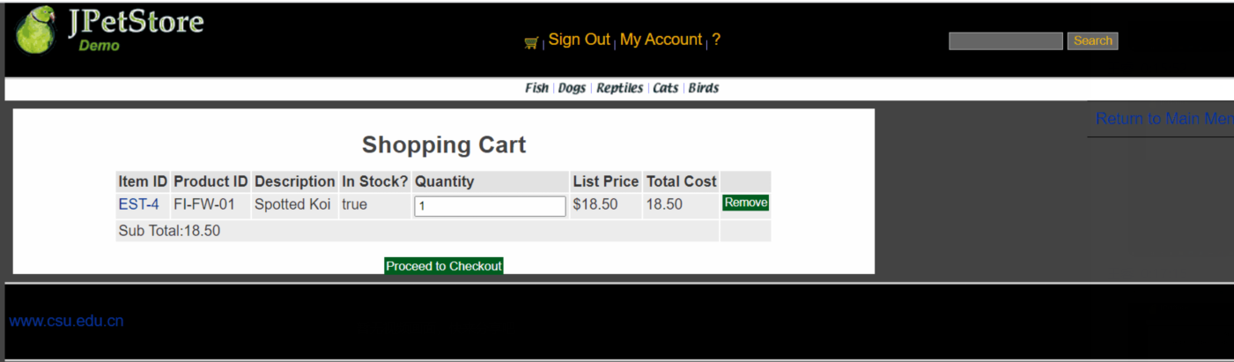

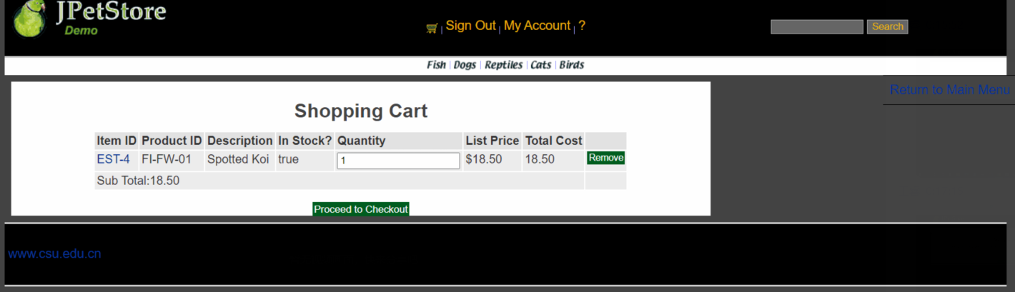
var httpRequest=null;
function createXMLHttpRequest(){
if(window.XMLHttpRequest) {
httpRequest = new XMLHttpRequest();
} else if (window.ActiveXObject) {
httpRequest = new ActiveXObject("Microsoft.XMLHTTP");
}
}
function updateCart() {
var quantity = document.getElementById("quantity").value;
sendRequest("updateCartJSServlet?quantity="+ quantity);
}
function sendRequest(url) {
createXMLHttpRequest();
httpRequest.open("GET",url,true);
httpRequest.onreadystatechange=processResponse;
httpRequest.send(null);
}
function processResponse() {
if (httpRequest.readyState == 4) {
if (httpRequest.status == 200) {
var resp = httpRequest.responseText;
var array = resp.split(",");
var quantity = document.getElementById("quantity");
var total = document.getElementById("total");
var subtotal = document.getElementById("subtotal");
quantity.innerText = array[0];
total.innerText = array[1];
subtotal.innerText = array[2];
}
}
}

//以上三个业务模块，用运行界面截图和核心代码展示功能完成情况。
- 实验内容——选做任务。
- 商品展示模块。在首页展示商品的图片上添加AJAX效果，即当鼠标移到某个商品图片上时，用悬浮窗展示该类型商品的信息。

原理：利用AJAX异步通信显示对应信息。

方案：在页面对id和相应网页图片进行绑定，在js中先获取category的id，在显示商品的id和名称。

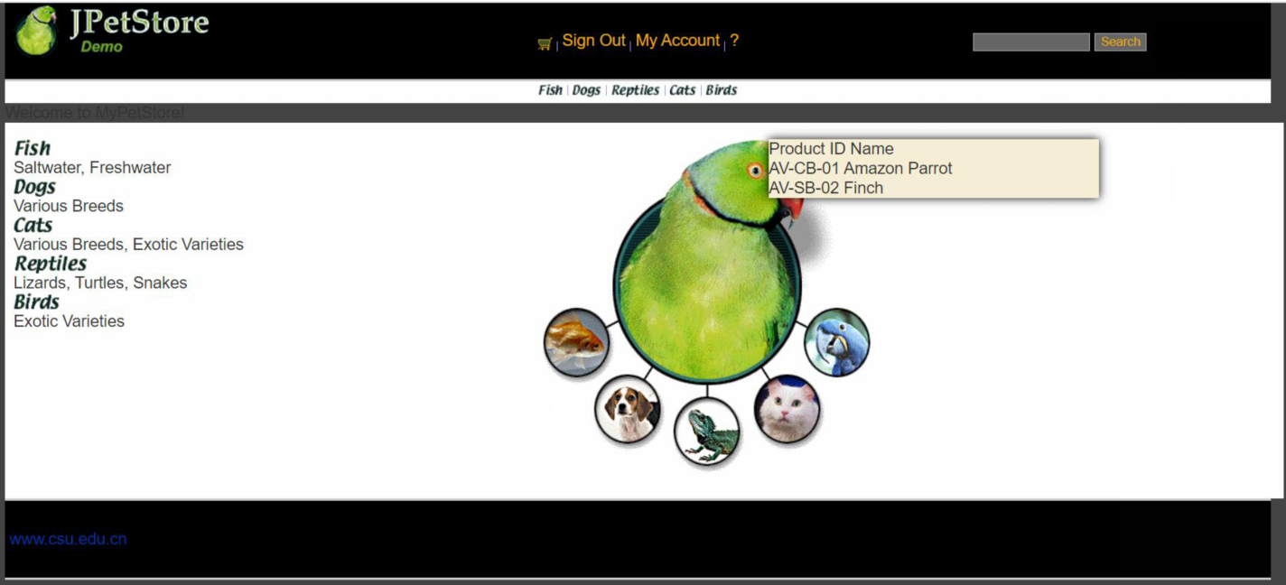
var httpRequest = null;
function createXMLHttpRequest(){
if(window.XMLHttpRequest) {
httpRequest = new XMLHttpRequest();
} else if (window.ActiveXObject) {
httpRequest = new ActiveXObject("Microsoft.XMLHTTP");
}
}
function showInform(categoryId) {
console.log(categoryId);
sendRequest("categoryShowJsServlet?categoryId=" + categoryId);
}
function sendRequest(url) {
createXMLHttpRequest();
httpRequest.open("GET",url,true);
httpRequest.onreadystatechange=processResponse;
httpRequest.send(null);
}
function processResponse() {
if (httpRequest.readyState == 4) {
if (httpRequest.status == 200) {
var resp = httpRequest.responseText;
//显示悬浮层
var inform = document.getElementById("inform");
inform.innerText = resp;
inform.style.display = "block";
}
}
}
//隐藏悬浮层
function hiddenInform(event){
var informDiv = document.getElementById('inform');
var x=event.clientX;
var y=event.clientY;
var divx1 = informDiv.offsetLeft;
var divy1 = informDiv.offsetTop;
var divx2 = informDiv.offsetLeft + informDiv.offsetWidth;
var divy2 = informDiv.offsetTop + informDiv.offsetHeight;
if( x < divx1 || x > divx2 || y < divy1 || y > divy2){
document.getElementById('inform').style.display='none';
}

- 订单模块。通过选项卡或模版内容实现订单多个信息部分的录入，不需要页面跳转，在一个页面完成订单所有内容的录入。

原理：通过AJAX功能改善后用户在数量框输入数量后，鼠标离开输入框，商品对应的信息改变。

方案：首先在jsp页面中设置通过html调用js中的功能，之后在页面中更改商品数量值，通过servlet更改对应信息，返回jsp页面上。

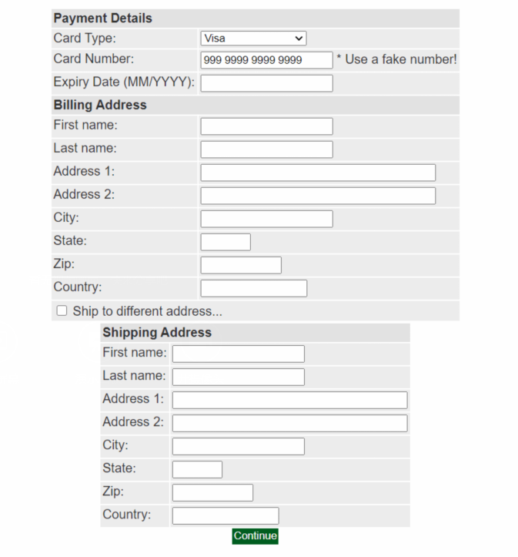

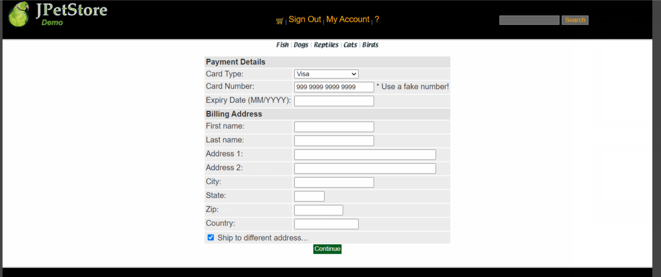
Array.prototype.unique = function(){
this.sort();
var res = [];
var json = {};
for (var i = 0; i < this.length; i++) {
if(!json[this[i]]){
res.push(this[i]);
json[this[i]] = 1;
}
}
return res;
}
// 对样式操作
var setClass = {
hasClass: function(elements,cName){ // 判断是否含有某个class
if(elements.className.match(new RegExp( "(\\s|^)" + cName + "(\\s|$)") ))
return true;
else
return false;
},
addClass: function(elements,cName){ // 添加class
if( !this.hasClass( elements,cName ) ){
elements.className += " " + cName;
};
},
removeClass: function(elements,cName){ // 移除某个class
if( this.hasClass( elements,cName ) ){
elements.className = elements.className.replace( new RegExp( "(\\s|^)" + cName + "(\\s|$)" )," " );
}
}
}
var Bind = function(This){
return function(){
This.init();
}
}
function AutoComplete(keyword,auto,arr) {
this.obj = document.getElementById(keyword);
this.autoObj = document.getElementById(auto);
this.search_value = ""; //当前的搜索输入值
this.index = -1; //当前选中的DIV的索引
this.value_arr = arr; //数据库中供检索的值 不包含重复值
}
AutoComplete.prototype = {
// 初始化
init: function(){
var This = this;
setClass.removeClass(This.autoObj,"hidden");
this.autoObj.style.left = this.obj.offsetLeft + "px";
this.autoObj.style.top = this.obj.offsetTop + this.obj.offsetHeight + "px";
},
//删除自动完成需要的所有DIV
deleteDIV: function(){
while(this.autoObj.hasChildNodes()){
this.autoObj.removeChild(this.autoObj.firstChild);
}
setClass.addClass(this.autoObj,"hidden");
},
autoOnmouseover: function(index){
if(index != this.index){
setClass.addClass(this.autoObj.children[index],"on");
setClass.removeClass(this.autoObj.children[this.index],"on");
this.index = index;
}
},
setValue: function(This){
return function(){
This.obj.value = this.seq;
setClass.addClass(This.autoObj,"hidden");
}
},
// 响应键盘
pressKey: function(event){
var code = event.keyCode;
var length = this.autoObj.children.length;
if(code == 38){ //↑
setClass.removeClass(this.autoObj.children[this.index],"on");
this.index--;
if(this.index < 0){
this.index = length - 1;
}
setClass.addClass(this.autoObj.children[this.index],"on");
this.obj.value = this.autoObj.children[this.index].seq;
}else if(code == 40){ //↓
setClass.removeClass(this.autoObj.children[this.index],"on");
this.index++;
if(this.index > length-1){
this.index = 0;
}
setClass.addClass(this.autoObj.children[this.index],"on");
this.obj.value = this.autoObj.children[this.index].seq;
}else{ //回车
this.obj.value = this.autoObj.children[this.index].seq;
setClass.addClass(this.autoObj,"hidden");
this.index = -1;
}
},
// 程序入口
start: function(event){
event = event || window.event;
var code = event.keyCode;
var This = this;
if(code != 13 && code != 38 && code != 40){
this.init();
this.deleteDIV();
this.search_value = this.obj.value;
var valueArr = this.value_arr.unique();
//去掉前后空格不能为空
if(this.obj.value.replace(/(^\s*)|(\s*$)/g,"") == ""){ return;}
//判断数组中是否含有输入的关键字
try{
var reg = new RegExp("("+ this.obj.value +")","i"); //输入"aaa" 则 reg = /(aaa)/i
}catch(e){
alert(e.message);
}
var div_index = 0; //记录匹配索引个数
for (var i = 0; i < valueArr.length; i++) {
if(reg.test(valueArr[i])){
var div = document.createElement("div");
div.className = "auto_out";
div.seq = valueArr[i];
div.index = div_index;
div.innerHTML = valueArr[i].replace(reg,"<strong>$1</strong>");
this.autoObj.appendChild(div);
setClass.removeClass(this.autoObj,"hidden");
div_index++;
if(div_index == 1) {
setClass.addClass(this.autoObj.firstChild,"on");
this.index = 0;
}
div.onmouseover = function(){
This.autoOnmouseover(this.index);
}
div.onclick = this.setValue(This);
}
}
}else{
this.pressKey(event);
}
window.onresize = Bind(This);
}
}
var xmlHttpRequest;
function createXMLHttpRequest()
{
if (window.XMLHttpRequest) //非IE浏览器
{
xmlHttpRequest = new XMLHttpRequest();
}
else if (window.ActiveObject)//IE6以上版本的IE浏览器
{
xmlHttpRequest = new ActiveObject("Msxml2.XMLHTTP");
}
else //IE6及以下版本IE浏览器
{
xmlHttpRequest = new ActiveObject("Microsoft.XMLHTTP");
}
}
var keyword = document.getElementById('keyword').value;
sendRequest("findResultServlet?keyword=" + keyword);
function sendRequest(url) {
createXMLHttpRequest();
xmlHttpRequest.open("GET", url, true);
xmlHttpRequest.onreadystatechange = processResponse;
xmlHttpRequest.send(null);
}
function processResponse() {
if (xmlHttpRequest.readyState == 4) {
if (xmlHttpRequest.status == 200) {
var resp = xmlHttpRequest.responseText;
//var resp2 = resp.split(',');
//var array = ['七里香','b0','b12','b22','b3','b4','b5','b6','如果爱','b7','b8','b2','abd','ab','acd','accd','abd','qq音乐','b1','cd','ccd','cbcv','小王子','cxf','b0'];
var array = resp.split(",");
var autoComplete = new AutoComplete("keyword","auto",array);
document.getElementById("keyword").onkeyup = function(event){
autoComplete.start(event);
}
}
}
}

- 小组成员分工及实验总结
- 小组分工：王睿为组长负责账号管理模块，查询商品模块以及商品展示模块，陈钰岭负责实现购物车模块以及订单模块。
- 实验总结
这次的实验二主要目的是对实验一进行优化，使用户的体验更加好，使用户更加方便。本次实验主要是对实验一的一些改进，使得用户在使用宠物商店时更加方便，比如设置了判断用户名是否已经存在。当用户名已经被注册过时就会显示用户名已经存在。即当新注册一个用户名时，程序会去数据库搜索是否有相同的用户名，如果有相同的用户名的话，则显示用户名已被注册，并且这个用户名不会再一次加入数据库。如果这个用户名未注册过，则显示注册成功，并加入数据库。之后我们还要加入订单模块的鼠标事件，当鼠标放置在相应的商品图片上时可以显示该商品的名称和编号。实现该功能主要是使用鼠标事件，然后从数据库中调出相应信息，并显示在页面上。
项目之后还实现了可以让用户在一个页面完成订单多个部分信息录入，而不需要页面跳转，大大节省了用户的时间以及提升效率。
总的来说，这次的实验二主要是对实验一进行改进优化，使用户体验更加完善，更加为用户着想。在一些细节方面更加注重，同时也是对自己的一个提升，让我们自己去想办法优化项目，去尽量让用户使用的舒心。我相信这对我们以后的学习工作都是有好处的，希望能通过这此的实验让我们对做出一个好的、完善的项目有一个更加完整的认识。

